Advanced SQL
Name: NALLANI LOKAKALYAN
Registered Mail: 2300030853cseh1@gmail.com

Exercise 1: Control Structures:

Scenario 1:
CREATE TABLE Customers (
CustomerID NUMBER PRIMARY KEY,
CustomerName VARCHAR2(50),
Age NUMBER
);
CREATE TABLE Loans (
LoanID NUMBER PRIMARY KEY,
CustomerID NUMBER,
LoanAmount NUMBER,
InterestRate NUMBER,
FOREIGN KEY (CustomerID) REFERENCES Customers(CustomerID)
);
INSERT INTO Customers VALUES (1, 'Praneeth', 65);
INSERT INTO Customers VALUES (2, 'Rahul', 45);
INSERT INTO Customers VALUES (3, 'Arjun', 70);
INSERT INTO Customers VALUES (4, 'Kiran', 55);
INSERT INTO Loans VALUES (101, 1, 500000, 10);
INSERT INTO Loans VALUES (102, 2, 300000, 9);
INSERT INTO Loans VALUES (103, 3, 700000, 11);
INSERT INTO Loans VALUES (104, 4, 400000, 8);
SELECT * FROM Customers;
SELECT * from Loans;
UPDATE Loans
SET InterestRate = InterestRate - 1
WHERE CustomerID IN (
SELECT CustomerID
FROM Customers
WHERE Age > 60
);
SELECT * FROM Loans;

Output Screenshot:
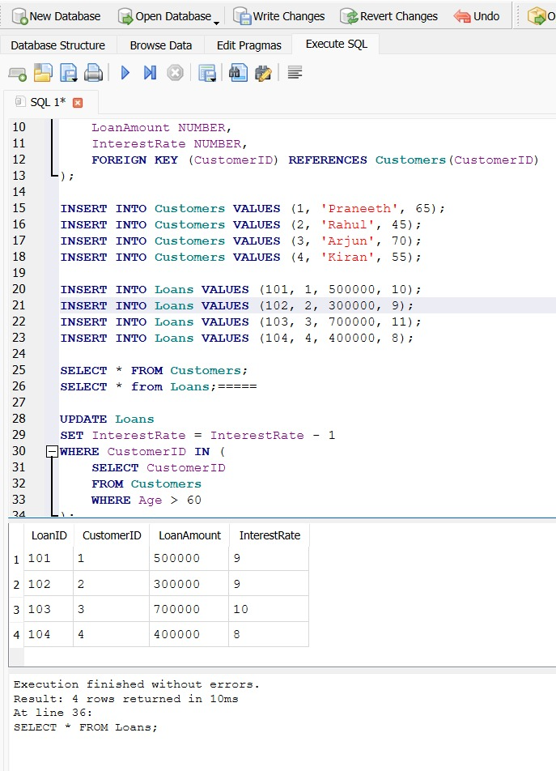
Scenario 2:

CREATE TABLE Customers1 (
CustomerID INTEGER PRIMARY KEY,
CustomerName TEXT,
Balance REAL,
IsVIP TEXT
);

INSERT INTO Customers1 VALUES (1,'Praneeth',15000,'FALSE');
INSERT INTO Customers1 VALUES (2,'Rahul',9000,'FALSE');
INSERT INTO Customers1 VALUES (3,'Arjun',25000,'FALSE');
INSERT INTO Customers1 VALUES (4,'Kiran',7000,'FALSE');

UPDATE Customers1
SET IsVIP = 'TRUE'
WHERE Balance > 10000;

SELECT * FROM Customers1;

Output Screenshot:
Scenario 2:
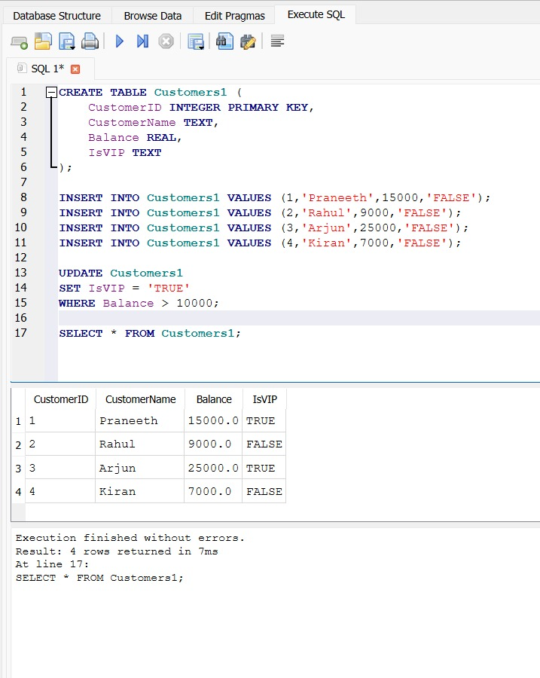

Scenario 3:
CREATE TABLE Loans1 (
LoanID INTEGER PRIMARY KEY,
CustomerName TEXT,
DueDate TEXT
);

INSERT INTO Loans1 VALUES (101,'Praneeth',date('now','+10 day'));
INSERT INTO Loans1 VALUES (102,'Rahul',date('now','+45 day'));
INSERT INTO Loans1 VALUES (103,'Arjun',date('now','+20 day'));
INSERT INTO Loans1 VALUES (104,'Kiran',date('now','+5 day'));

SELECT
CustomerName,
'Reminder: Your loan is due on ' || DueDate AS Reminder
FROM Loans1
WHERE DueDate BETWEEN date('now') AND date('now','+30 day');

Output Screenshot:
Scenario 3:
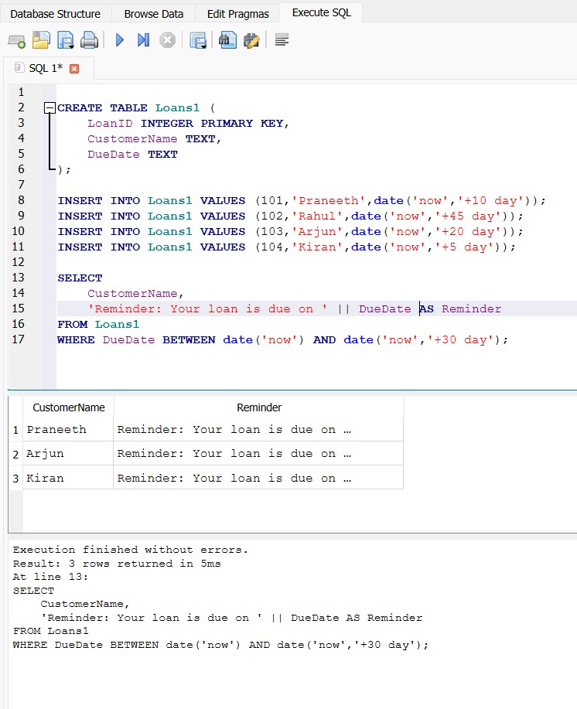

Exercise 3: Stored Procedures:
Scenario 1:

CREATE TABLE Accounts (
AccountID INTEGER PRIMARY KEY,
CustomerName VARCHAR(50),
AccountType VARCHAR(20),
Balance INTEGER
);

INSERT INTO Accounts VALUES (101, 'Praneeth', 'Savings', 50000);
INSERT INTO Accounts VALUES (102, 'Rahul', 'Savings', 30000);
INSERT INTO Accounts VALUES (103, 'Arjun', 'Current', 40000);
INSERT INTO Accounts VALUES (104, 'Kiran', 'Savings', 70000);

UPDATE Accounts
SET Balance = Balance * 1.01
WHERE AccountType = 'Savings';

SELECT * FROM Accounts;

Output Screenshot:
Scenario 1:
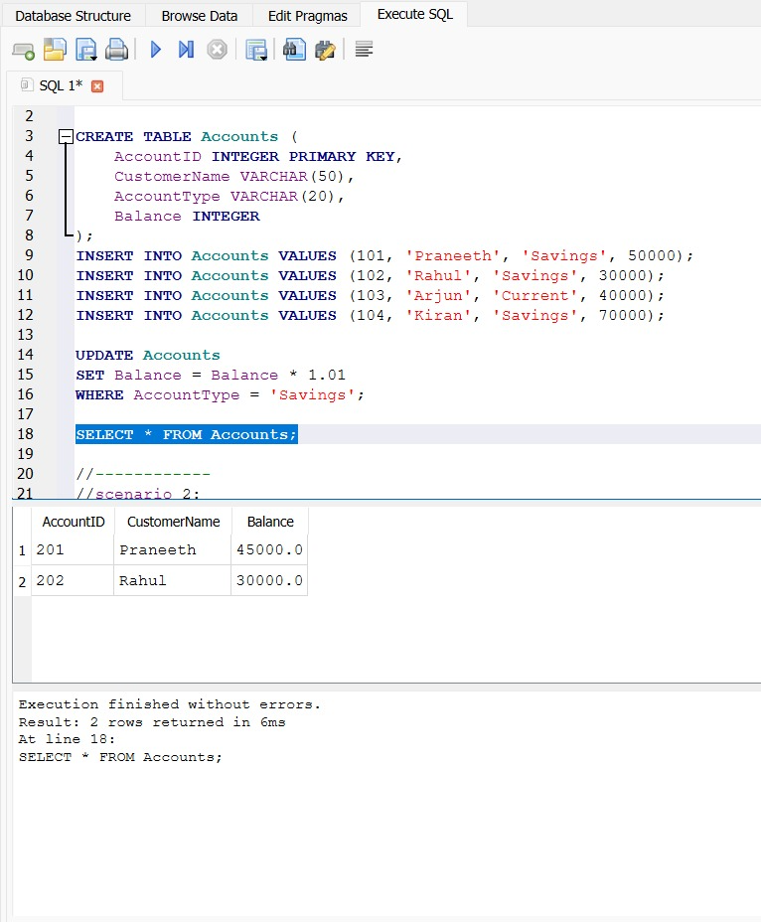

Scenario 2:

CREATE TABLE Employees (
EmployeeID INTEGER PRIMARY KEY,
EmployeeName TEXT,
Department TEXT,
Salary REAL
);

INSERT INTO Employees VALUES (1,'John','IT',50000);
INSERT INTO Employees VALUES (2,'David','HR',45000);
INSERT INTO Employees VALUES (3,'Alice','IT',60000);
INSERT INTO Employees VALUES (4,'Bob','Finance',55000);

UPDATE Employees
SET Salary = Salary + (Salary * 10 / 100)
WHERE Department = 'IT';

SELECT * FROM Employees;

Output Screenshot:
Scenario 2:

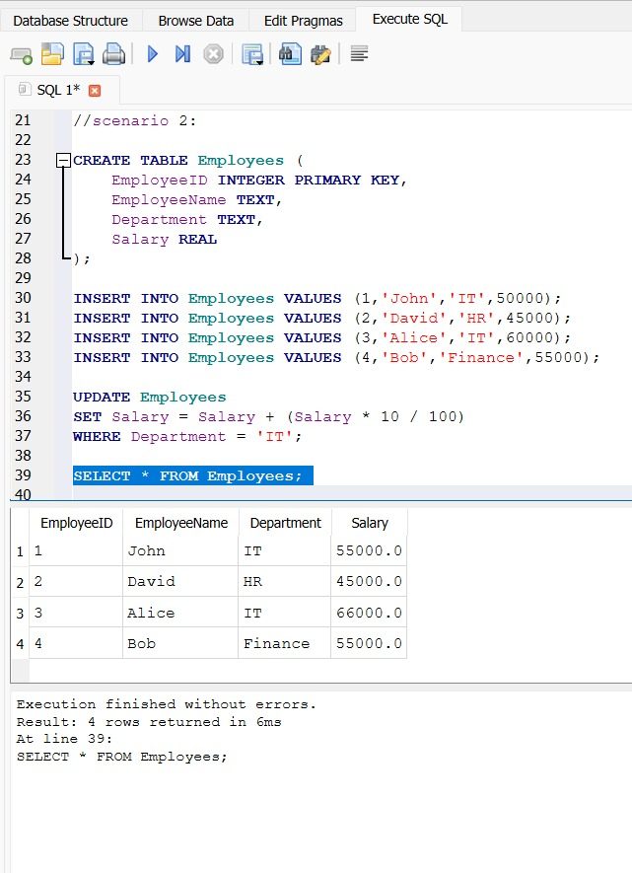

Scenario 3:

DROP TABLE IF EXISTS Accounts;

CREATE TABLE Accounts (
AccountID INTEGER PRIMARY KEY,
CustomerName TEXT,
Balance REAL
);

INSERT INTO Accounts VALUES (201,'Praneeth',50000);
INSERT INTO Accounts VALUES (202,'Rahul',25000);

UPDATE Accounts
SET Balance = Balance - 5000
WHERE AccountID = 201
AND Balance >= 5000;

UPDATE Accounts
SET Balance = Balance + 5000
WHERE AccountID = 202;

COMMIT;

SELECT * FROM Accounts;

Output Screenshot:
Scenario 3:
